HOME

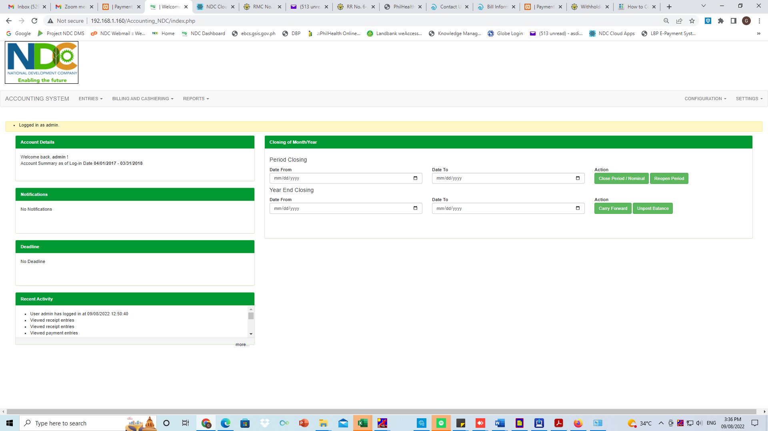

ENTRIES

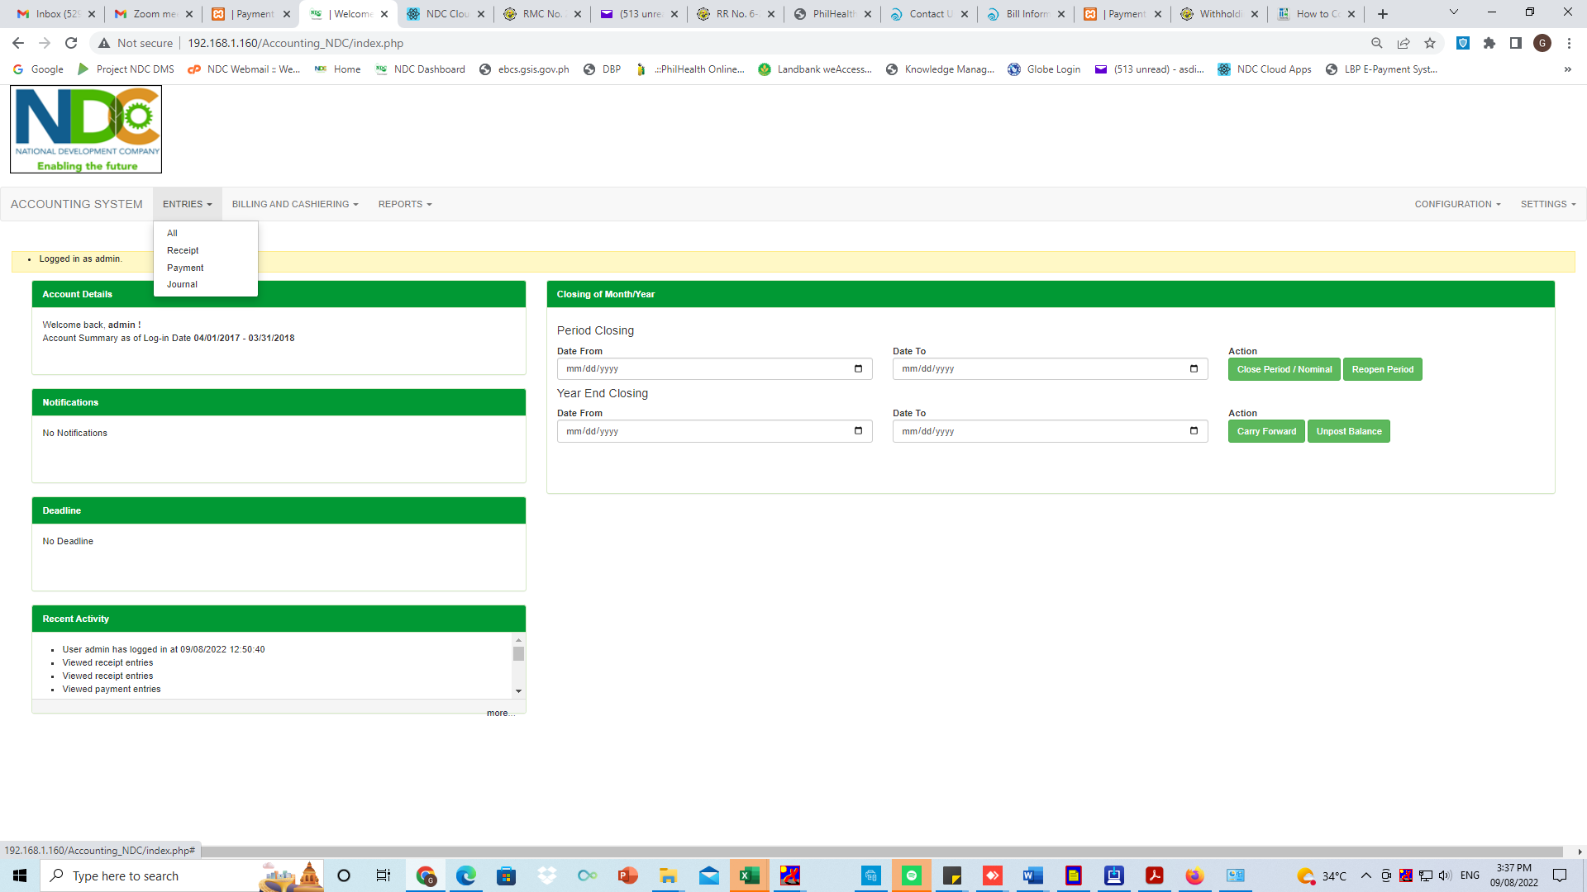

* RECEIPT
* ADD RECEIPT ENTRY

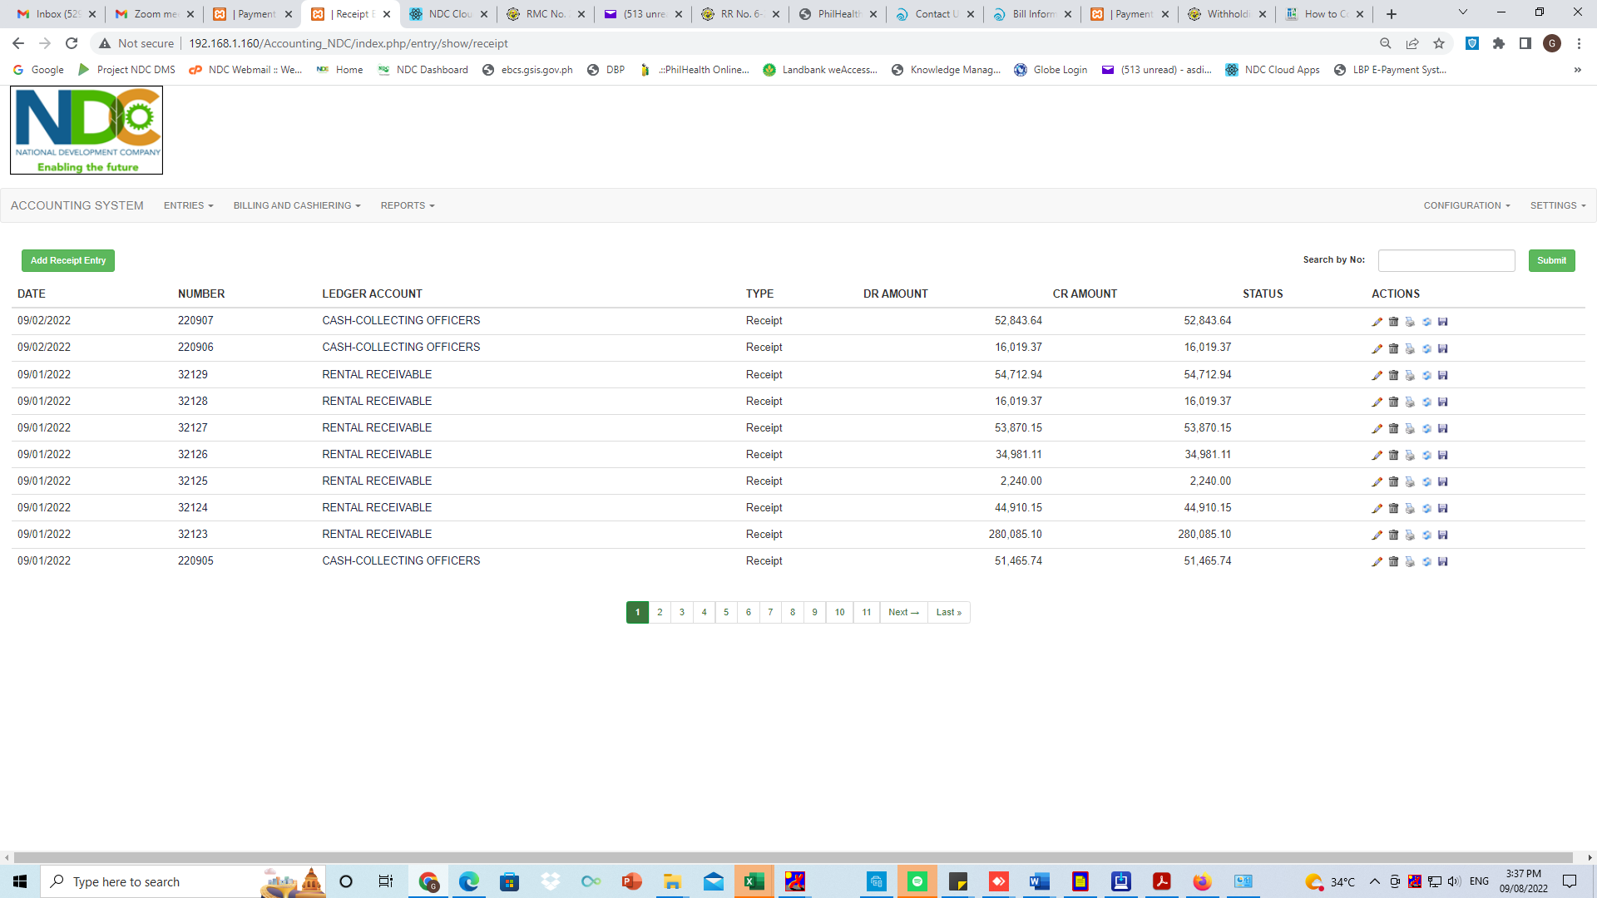

* CREATING RECEIPT ENTRY

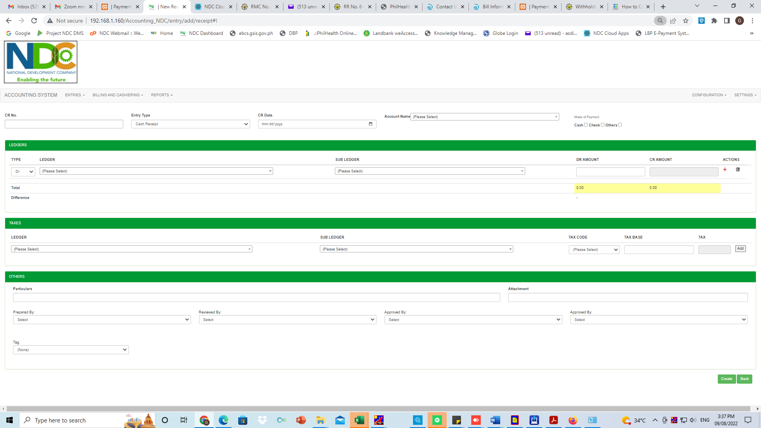

* PAYMENT ENTRY
* ADD PAYMENT ENTRY

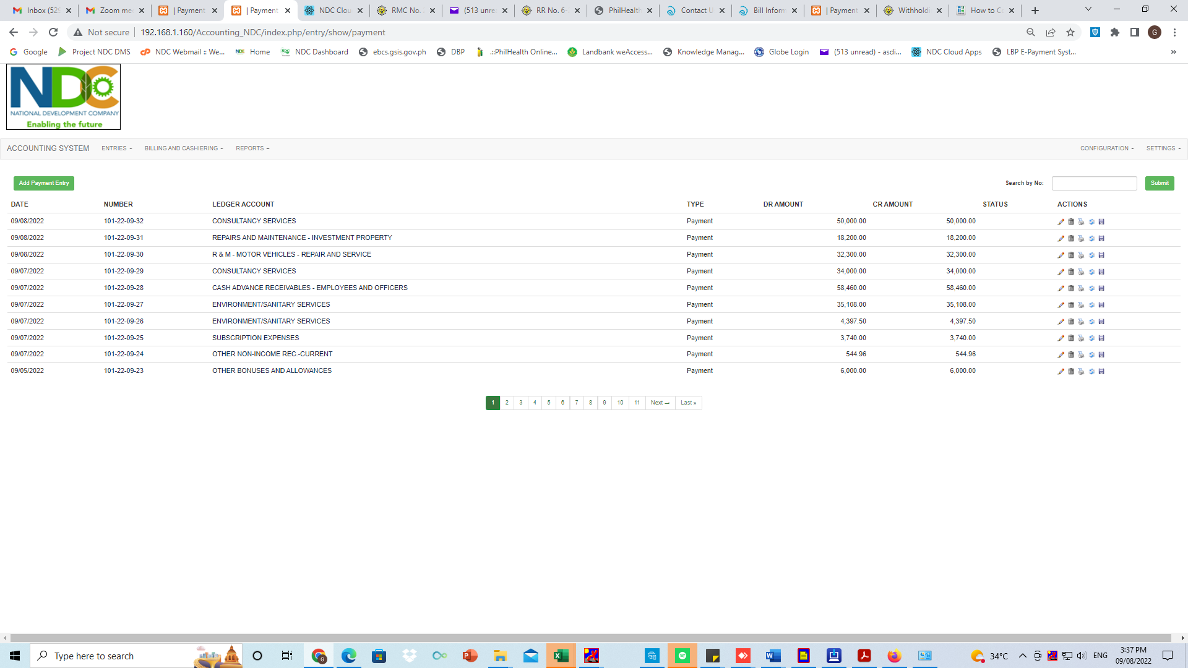

* CREATING PAYMENT ENTRY

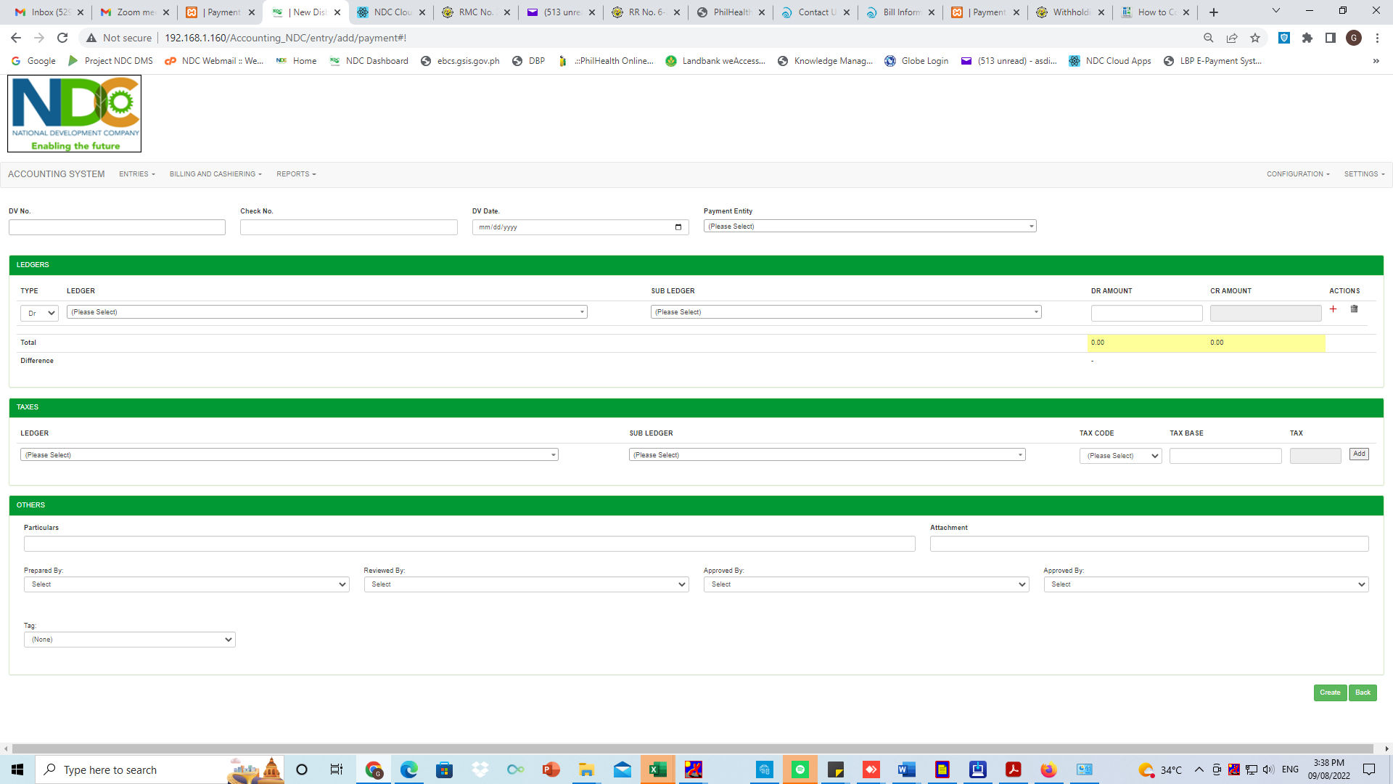

* JOURNAL ENTRY
* ADD JOURNAL ENTRY

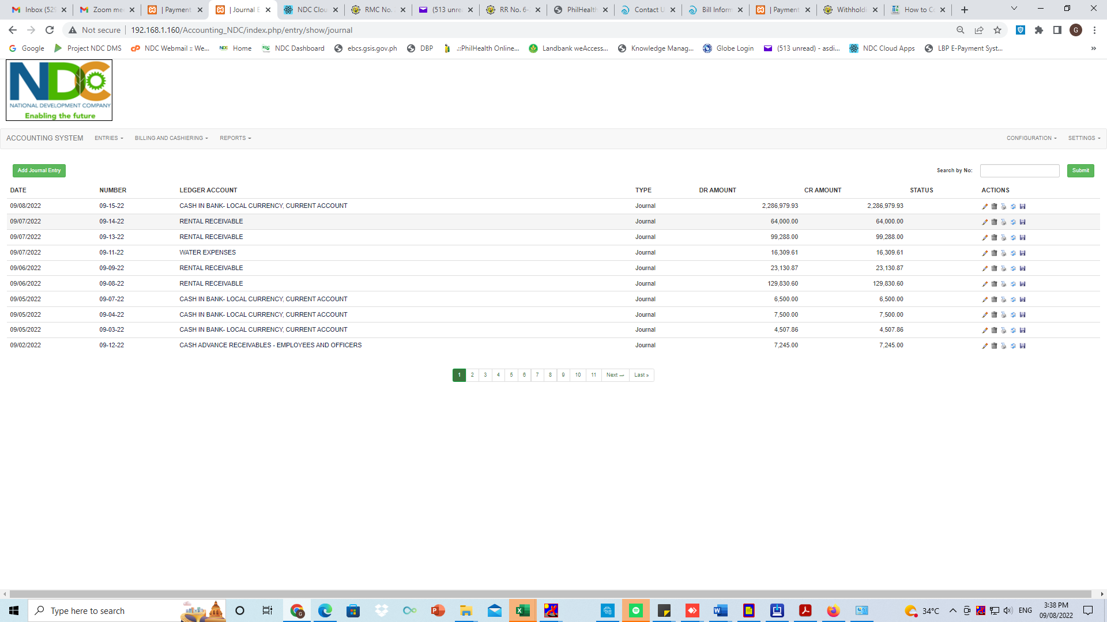

* CREATING JOURNAL ENTRY

